# Business card reader

We will create a canvas app starting with data. We will then connect the data to our CDS data and build out our input form. We can then add the Business card reader control from the new AI Builder options. After the input form is ready, we can map the data to create records. Finally, we test the app we’ve created.

# Exercise 1

In this first exercise, we will build the shell of a canvas app with our input screen.

1. From PowerApps maker experience, select Apps-> Create an app->Canvas.

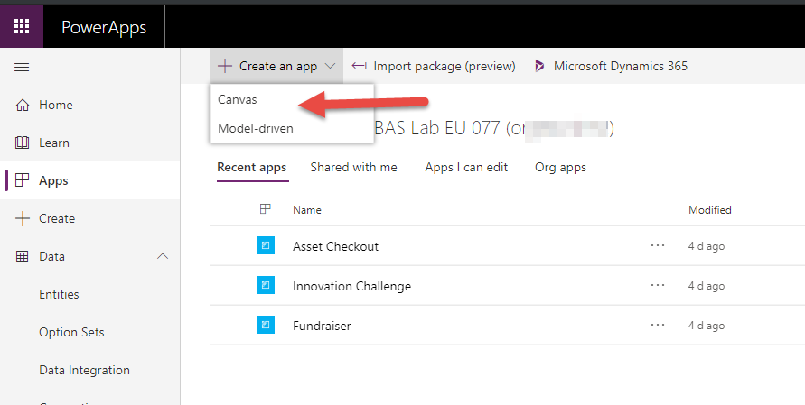

1. Select Start with your data; Common Data Service Phone layout.

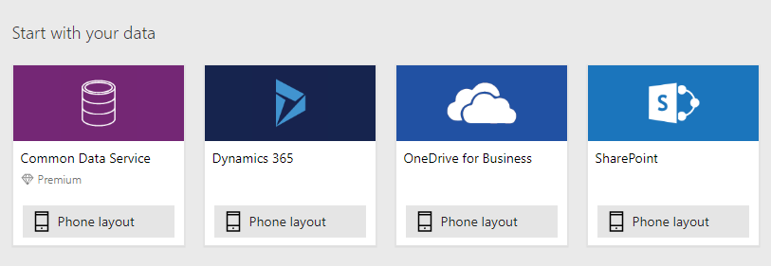

1. Choose the Contacts table and Connect.

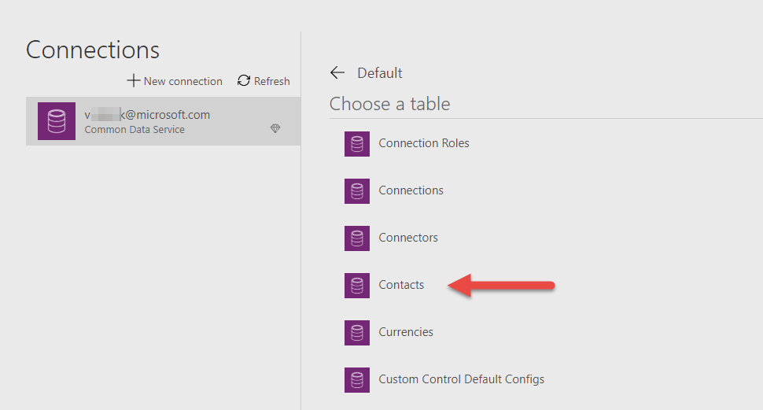

1. The system will now build your starter app. Your screen should look like the image below.

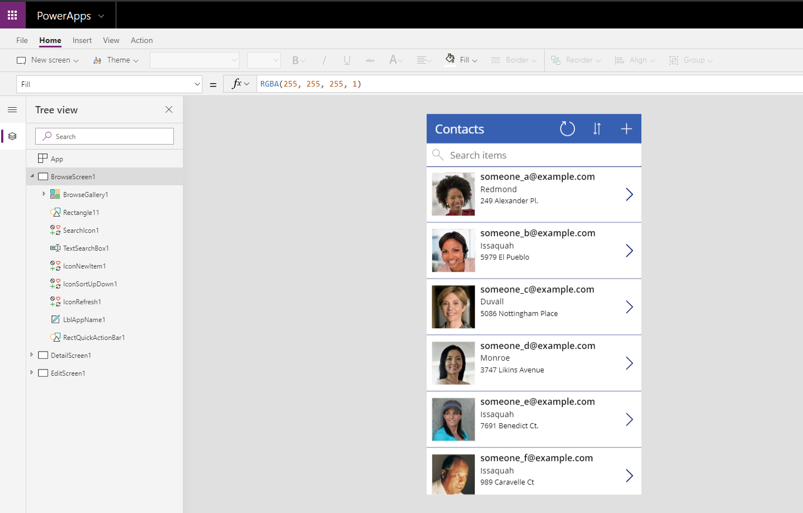

1. On the Tree view on the left, expand the EditScreen1 and select EditForm1.  
     
   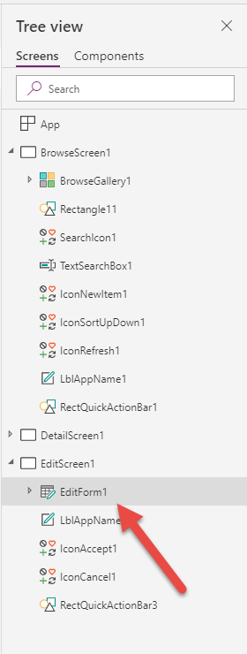
2. Select Edit Fields from the pane on the right.  
     
   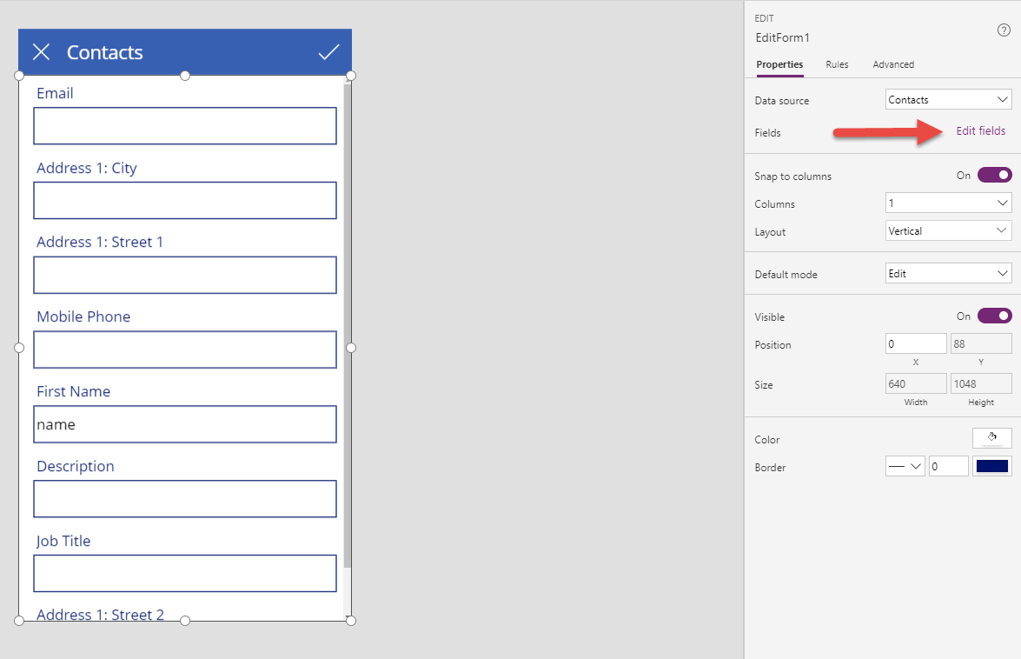
3. You can now add, remove and re-order fields here.

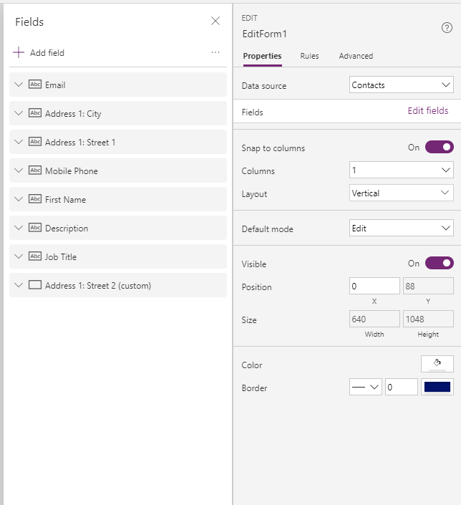

1. Add Last Name. Last Name is a required field for CDS Contact records.   
     
   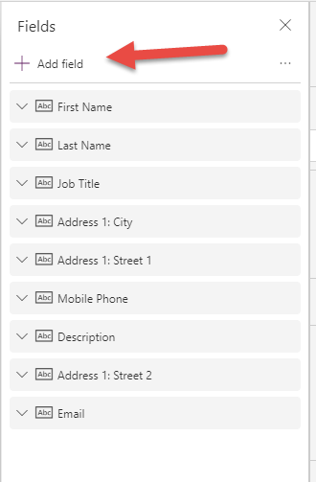
2. Reorder your fields like in the image below. You can remove extra fields (or leave them).

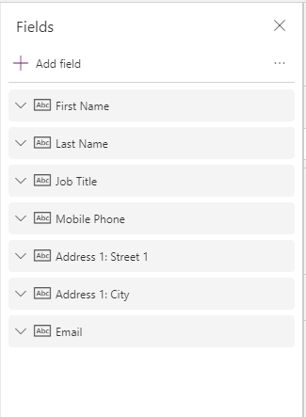

1. Drag the EditForm1 control to make it smaller and allow room for the Business Card Reader to be added to the screen.

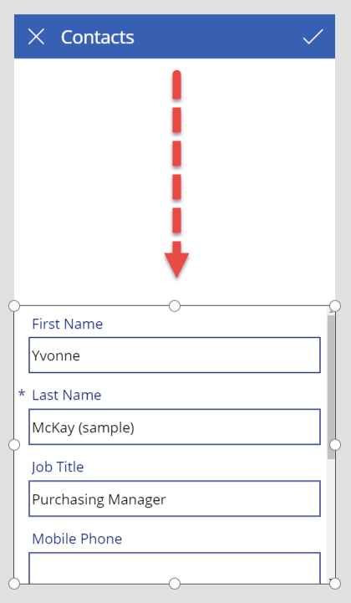

1. From the Insert ribbon tab, select AI Builder and Business Card Reader.

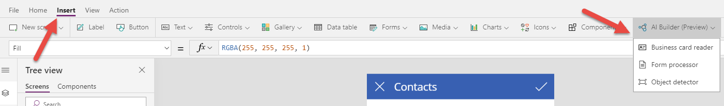

1. The Business Card Reader Control will be placed on your working canvas.

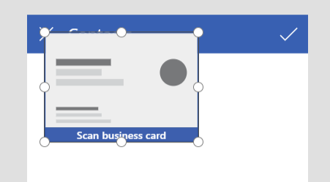

1. Drag and resize and move the Business Card Reader control to fit the available space on the screen. Do not leave this screen.

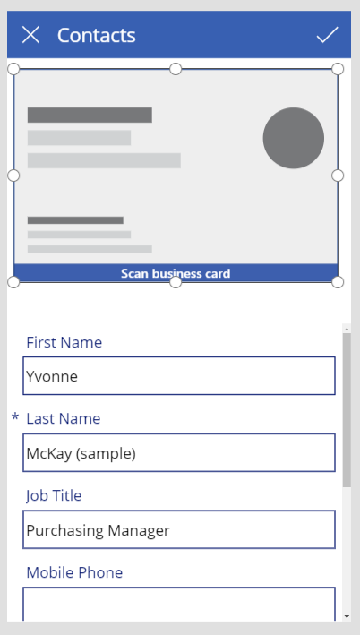

|  |  |
| --- | --- |
| Head with gears | ***Did you know…*** it’s considered a best practice to rename items in your canvas app and give them logical names? For example, instead of label1 or button3 you could edit the name and call them labelName or submitbutton? This makes it easier to remember items and their purpose later, and it makes for a more productive team approach to making apps. |

# Exercise 2

We will now map the data from the card reader to the CDS fields and edit the gallery view to show our preferred fields.

1. From the Tree view, expand EditScreen1 -> EditForm1 ->First Name_DataCard2 and select DataCardValue13.  
     
   **\*\*Note:** the numbers you see after the labels here may differ; look for the keywords like labels and forms that we reference here.

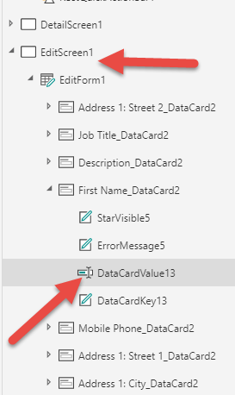

1. From the editing pane on the right, select Advanced, and then Unlock to allow for editing.

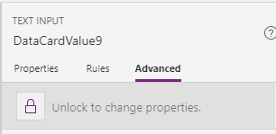

1. In the Data->Default field change the text to read:

BusinessCardReader1.FirstName

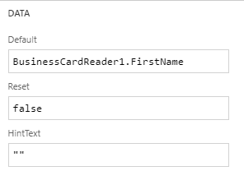

1. Repeat this for the fields you wish to map from the reader to the contact record. The pattern to follow is: BusinessCardReader1.FieldName. You can use intellisense to help you find the field names if needed. Map at least **LastName** and **JobTitle.** You can also map a few more fields so you can see the results when you test.
2. Expand BrowseScreen1 and expand BrowseGallery1. Select Title1 and change it to map FirstName.  
     
   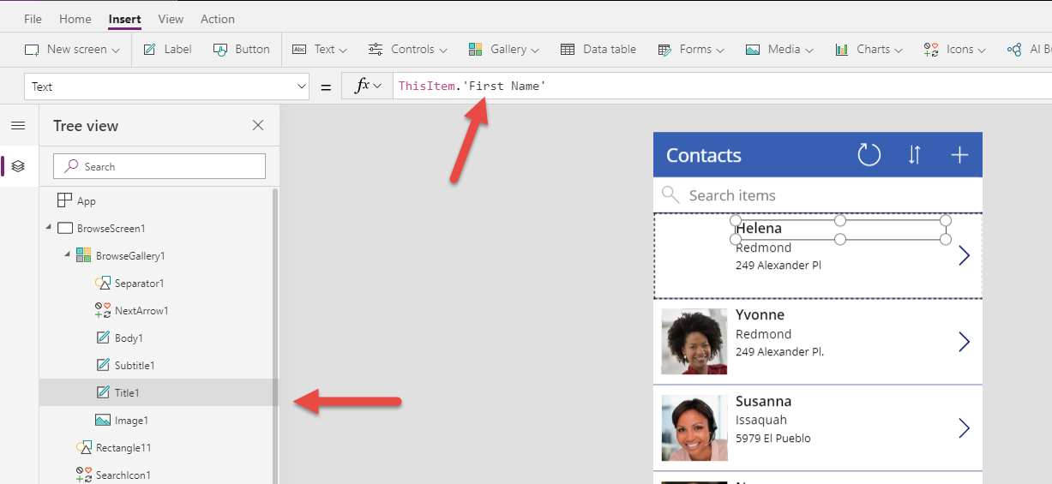
3. Now change Subtitle1 to be Last Name and Body to be Job Title.  
     
   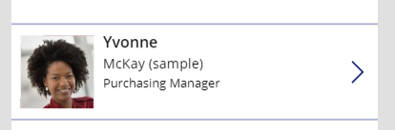

# Exercise 3

Now we will test the app.

1. Set focus to the BrowseScreen1 screen in the Tree View.  
     
   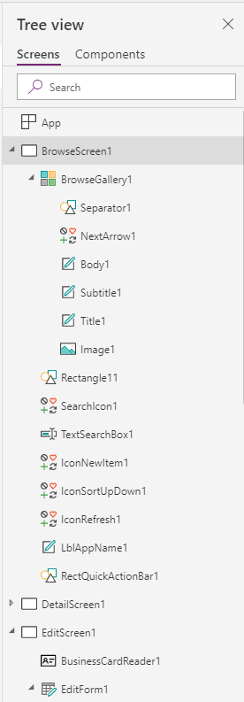
2. Select Play to preview the app.

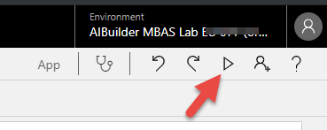

1. Click the plus icon to launch the add screen.

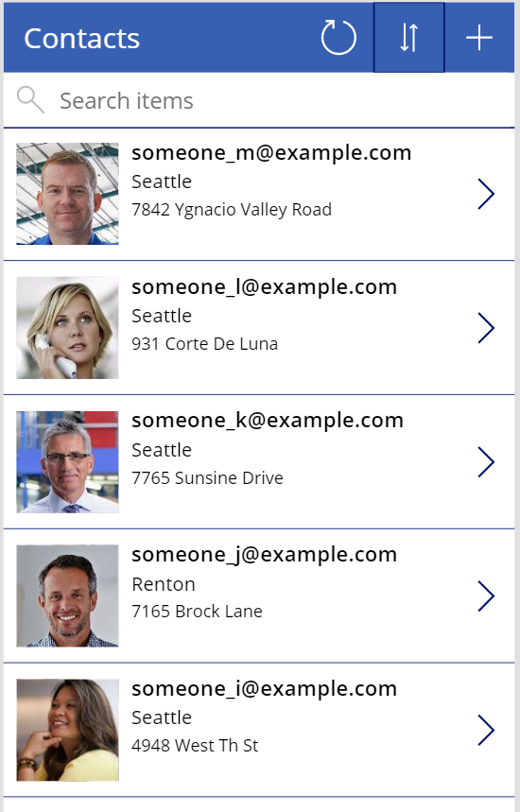

1. Click/select the Scan Business Card control and select the image with the business card in your student materials.

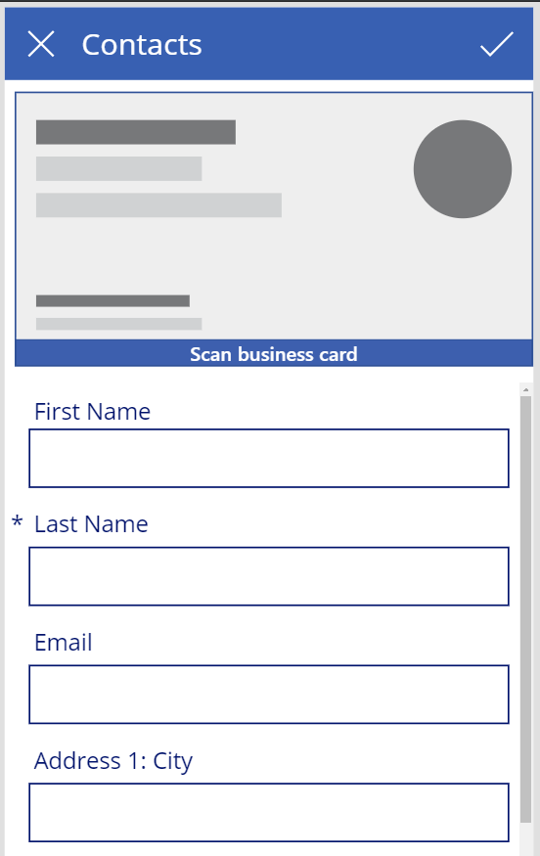

1. The card reader will locate the card and map the selected fields.

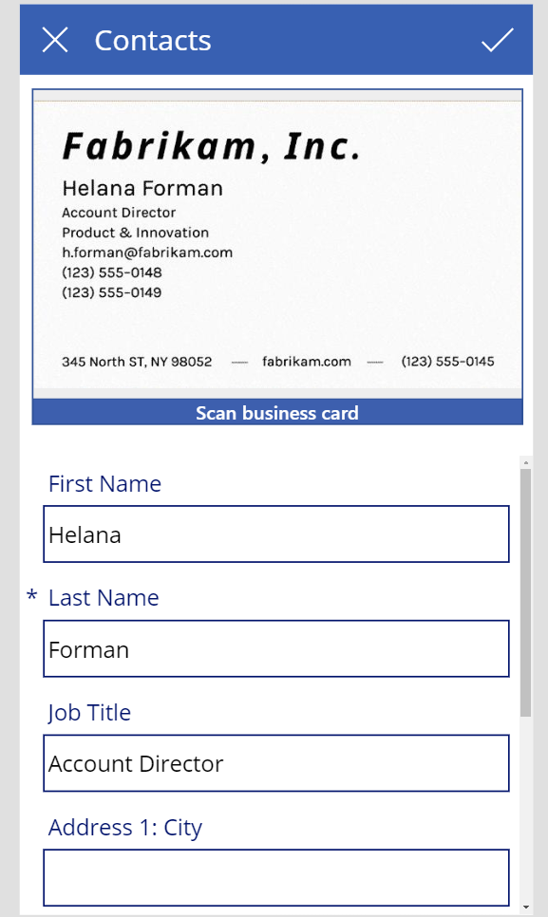

1. Click/select the check to create the record. Your new contact record should now show.

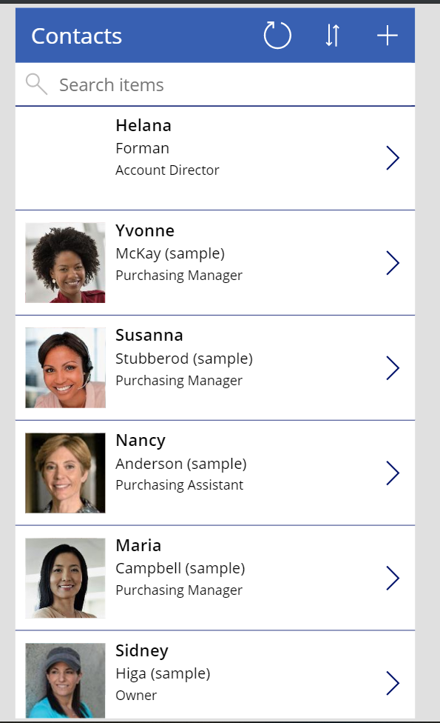

1. Close the preview.
2. We will now name and save our app. Click File.  
     
   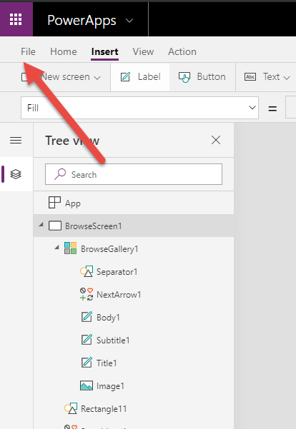
3. Click Save As and give your app a name.  
     
   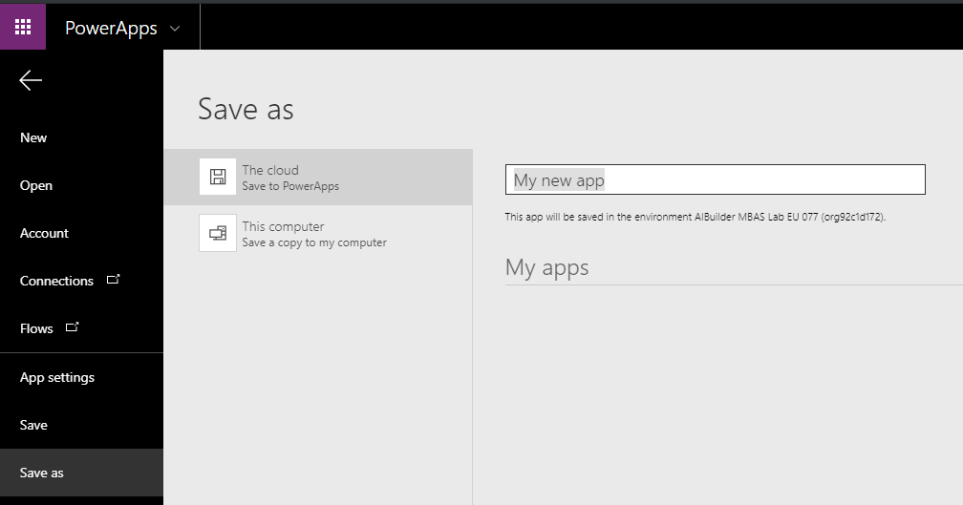
4. You can return to your app maker by clicking the back button in the top left corner (not your browser back button)  
   